**Angular 19.**

**What is Component?**

A **Component** is a fundamental building block of the application.

It controls a portion of the UI and is responsible for managing the data and logic associated with that part of the view.

Components are reusable, making it easier to build and maintain complex applications.

 It is a TypeScript class decorated with the @Component decorator

Components can communicate with each other using @Input and @Output decorators.

**(“*Components also support dependency injection, making it easy to manage services and share data across the application."***

***"With the introduction of Signals in Angular 16+, components can now efficiently track and update state with better performance.*”)**

**Key Features of an Angular Component:**

1. **Template**:
   * The template defines the HTML structure of the component. It determines how the component is rendered in the DOM.
   * It can include Angular-specific syntax like data binding, directives, and event handling.
2. **Class**:🡪Behaviour logic
   * The TypeScript class contains the logic for the component, such as handling user interactions, making API calls, or managing data.
   * It uses the @Component decorator to define metadata about the component (e.g., selector, template, styles).
3. **Metadata**:
   * The @Component decorator provides metadata that tells Angular how to process the component.
   * Metadata includes properties like selector, templateURL, styleURLs, etc.
4. **Styles**:

The component can also include styles (CSS/SCSS) that are scoped to the component, ensuring they don't affect other parts of the application.

1. **Selector**:
   * The selector is a custom HTML tag (e.g., <app-my-component>) used to embed the component in other templates.

**Lifecycle of a Component:**

Angular components have a lifecycle managed by Angular. Key lifecycle hooks include:

ngOnInit(): Called after the component is initialized.

ngOnChanges(): Called when input properties change.

ngOnDestroy(): Called before the component is destroyed.

**Why Use Components?**

* **Reusability**: Components can be reused across the application.
* **Modularity**: Each component encapsulates its logic, template, and styles.
* **Maintainability**: Breaking the UI into smaller components makes the code easier to manage and test.

**How to create component?**

For component creation use command   
ng generate component <component name> **(or)** ng g c <component name>

Each component contains below files.

app.component.html--->HTML code UI representation

app.component.css---> CSS code - Stylesheet (styling)

app.component.ts--> TypeScript class (logic), process and render the component.

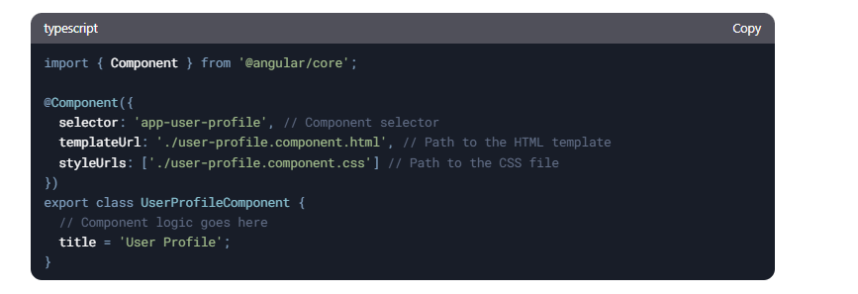

app.component.specs.ts Unit test file

**What is Component Decorator ?**

**Component Decorator** is a special **TypeScript decorator** (@Component) that marks a **class** as an Angular component. It provides **metadata** that tells Angular how to process and render the component.

The @Component decorator is mandatory for defining a component in Angular.

It provides metadata about the component, such as its selector, template, and styles.

You can use external files (templateUrl, styleUrls) or inline properties (template, styles).

The decorator makes the component reusable and modular.

**How to Render component ?**

Basic rendering: Use <app-my-component></app-my-component> in a template.

Dynamic rendering: Use ViewContainerRef and ComponentFactoryResolver.

Routing-based rendering: Define routes and use <router-outlet>.

Example:

imports: [DataBindingComponent], in app.component.ts

<app-data-binding></app-data-binding> in app.component.html

**OR**

**create single File component ?**

instead of having html and css, specs.ts and ts we can have only ts file with help of directive.

use template and styles instead of templateURL and styleUrls in Component decorator.

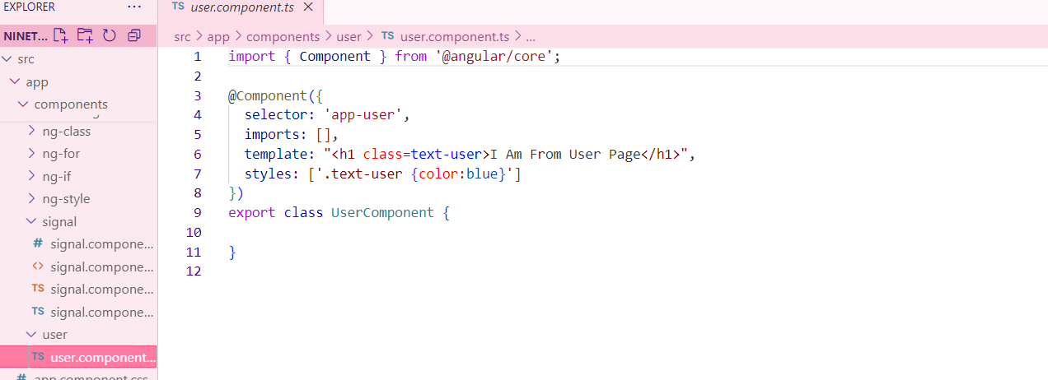

**What is standalone component ?**

A Standalone Component in Angular is a self-contained component that does not need to be declared inside an NgModule. This feature was introduced in Angular 14 to simplify application structure by reducing the need for modules.

ng g c my-component --standalone

**How to Declare Variable / state in Component?**

In Angular, you can declare variables (state) inside the component class using TypeScript properties.

**What is Data Binding ?**

Data Binding in Angular is the mechanism that connects the component's data (TypeScript logic) with the view (HTML template). It ensures that changes in the component reflect in the UI and vice versa.

There are four main types of data binding in Angular:

1. **Interpolation** - {{}} → One-way binding from component to view
2. **Property Binding** - [property] → One-way binding from component to an HTML element
3. **Event Binding** - (event) → One-way binding from UI to the component
4. **Two-Way Binding** - [(ngModel)] → Two-way sync between component and UI

**What is Directive ?**

A Directive in Angular is a special type of class that allows you to modify the behavior, appearance, or structure of DOM elements.

Directives are used to extend HTML capabilities and add dynamic behavior to elements in Angular applications.

Hint: Whenever you need to use ngModel, the name attribute is mandatory.

Inside a class, we must declare a variable with a data type so that it can be used for display.

If we need to show data on page load, we must define it in the constructor.

Many events are available, for example: mouseover, dblclick, change, and click.

**What Are Types of Directive?**

Angular has three types of directives:

1. Component Directives (Most Common) → Directives with a template (@Component)
2. Structural Directives → Modify the DOM structure (*ngIf, *ngFor, *ngSwitch)
3. Attribute Directives → Modify the appearance or behavior of an element ([ngClass], [ngStyle], Custom directives)

To use ngModel, you must import FormsModule in the module file (e.g., app.module.ts) and include it in the imports array: imports: [FormsModule]. Similarly, for *ngIf, you need to import NgIf, and for *ngFor, you need to import NgFor.

**How to use ngModel directive ?**

Helps in capturing user input value:

[(ngModel)] = "declaredVariable"

{{ declaredVariable }} → The user input value will be displayed.

[ngClass]="isChecked ==true? ‘’:’’ ">

If you want to assign the value entered in a text box to another field using ngModel, you can do this by updating the second field dynamically in the component.

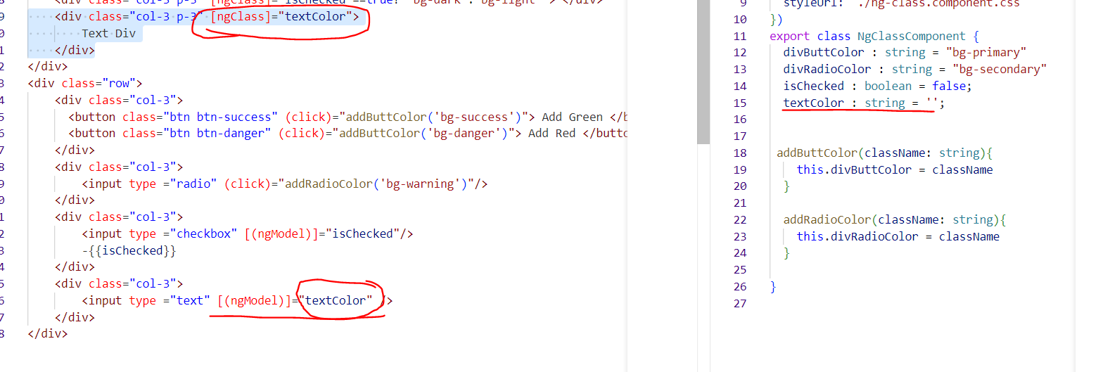

**What Are Structural Directive ?**

**How to use *ngIf Directive ? or How to Hide and Show Element in Angular ?**

The *ngIf directive is used to conditionally display elements based on a boolean condition

**How to use *ngFor Directive ? or How to Create Dynamic Element in Angular ?**

**Dynamic: dynamic behavior refers to the ability to change content, styles, properties, or data dynamically based on user interactions, API responses, or conditions.**

The *ngFor directive is used to loop through arrays and dynamically create elements.

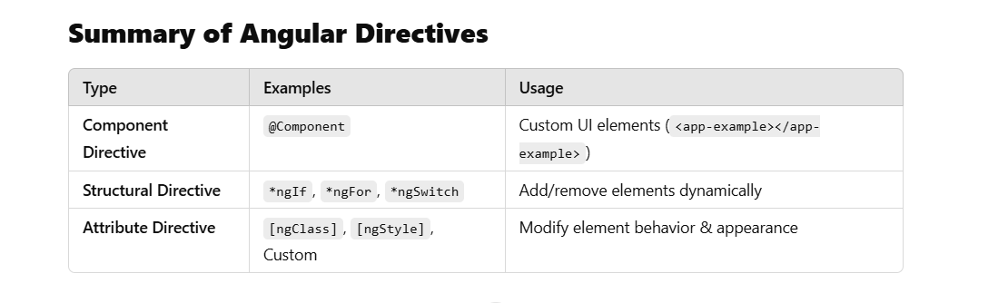

**Use *ngIf to conditionally display elements.  
Use *ngFor to loop through arrays and generate elements.  
Use [hidden] or [ngStyle] to toggle visibility.  
Use Renderer2 for advanced dynamic element creation.**

**In order to use the NgIf directive, structural directives, or attribute directives, we need to import CommonModule or NgIf in component.ts under imports: [NgIf].**

**To hide or show an element, we must use *ngIf on that element in older Angular versions.**

**NgFor (for loop, iterator) dynamically creates elements.**

**Structural Directives (modify the DOM): *ngIf, *ngFor, *ngSwitch.**

**Attribute Directives (modify the appearance): [ngClass], [ngStyle].**

**Using the [ngClass] directive, we can dynamically assign CSS classes to an element.**

**What Are Attribute Directive ?**

**How to use [ngClass] Directive ? and How to Add Dynamic Class ?**

In order to use ngclass either import**: commonModule** or **NgClass** in .ts file.

The declared variable needs to assign for ngClass.

**[ngClass]=”divColor”**

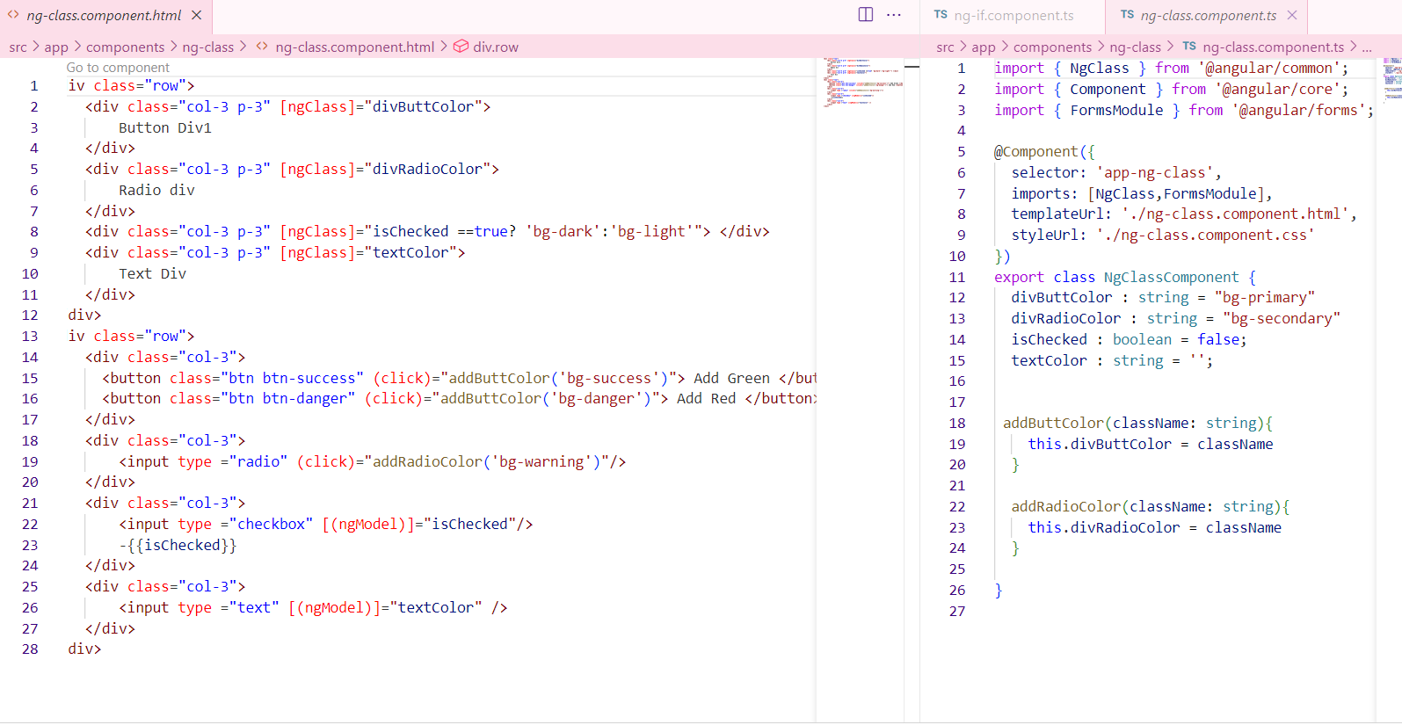

**How to use [ngStyle] Directive ? and How to Add Dynamic CSS / Style?**

Using of ngStyle added background color to the variable.

**2nd example:**

**What is Control Flow Statement ?**

**ngIf and ngFor needs to import: commonModule** or **NgIf/NgFor**

**How To use @if, @else if , @else ?**

**How to use @for ?**

**What is Signal ?**

When a change is detected, **Zone.js** will detect it and update the UI. Even if **Zone.js** is turned off, signals will still detect changes.

To simplify state management and change detection. They help track and react to changes in data more efficiently.

**How to Create Signal And Update Signal ?**

Creation of signal is like same as variable except there is keyword signal.

We can create signal with and without data type.

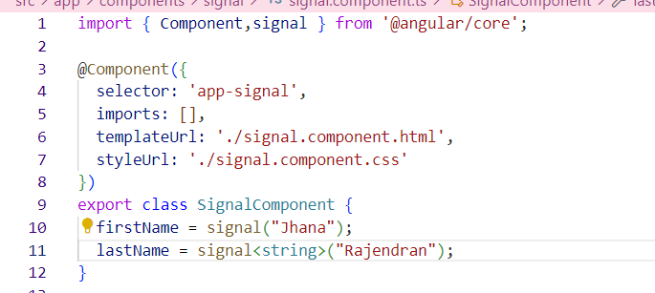

**How to Access Signal Value ?**

**We can access value as a method.**

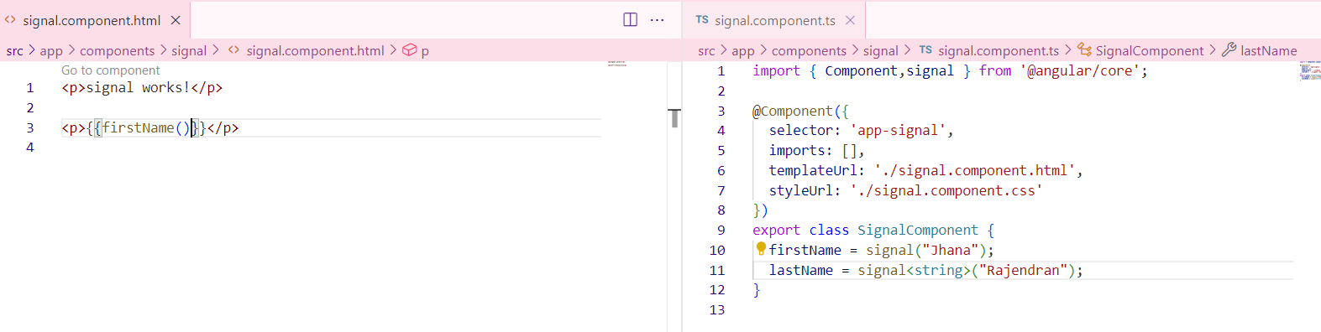

**How to use set , update method ?**

**What is Linked Signal ?**

If there is a dependent signal, and one of the signals changes, the linked signal (or computed signal) will automatically update. This is because computed signals track dependencies and recalculate when any of their dependencies change.

**How to Create Linked Signal?**

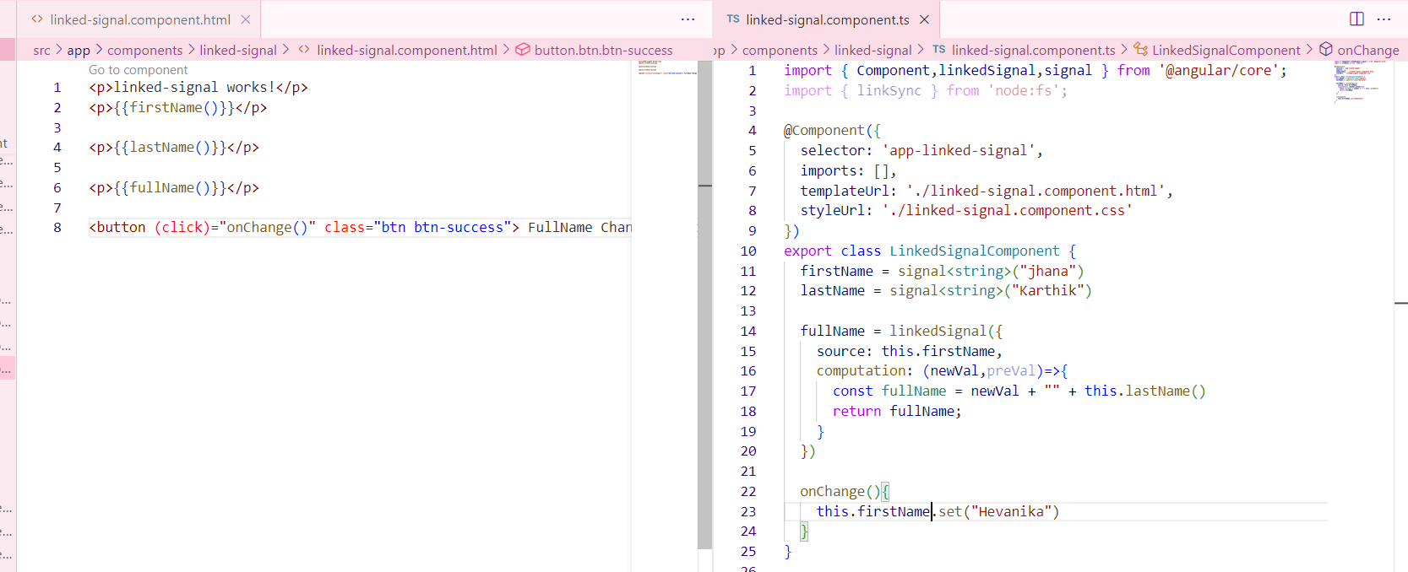

**What is computation and equal in Linked Signal ?**

**What is Routing ?**

Notes: Creating a URL for your components.

Starting from Angular 19, a constant file app.routes.ts is generated by default. In Angular, a route is an object that defines a path and its associated component.

Routing in Angular enables navigation between different views (components/pages) within a Single Page Application (SPA). It allows users to switch between pages without a full-page reload, providing a smoother experience.

**How to Create Routes ? AND How to Create Default Route ?**

Default route will be declared as.

Declare the necessary routes in app.routes.ts and pass this route to app.config.ts.

**What is router-outlet ? AND What is RouterLink ?**

When using navigation links in app.component.html, you must include <router-outlet> to display routed components.

The rule is that whatever you need to use must be imported in app.component.ts. For example, <router-outlet> must be imported in app.component.ts

**How to do Navigation in Angular ?**

By using router link we can achieve navigation.

In order to perform navigation from .html file use routerLink=

In order to perform logical navigation from .ts file must use router services.

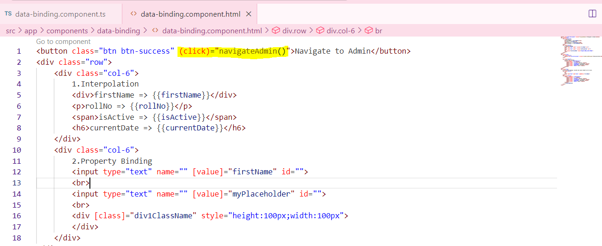

**Form Types in Angular ?**

Bind an object to a form using ngModel is called Template Form.

**How to Create Template Form ?**

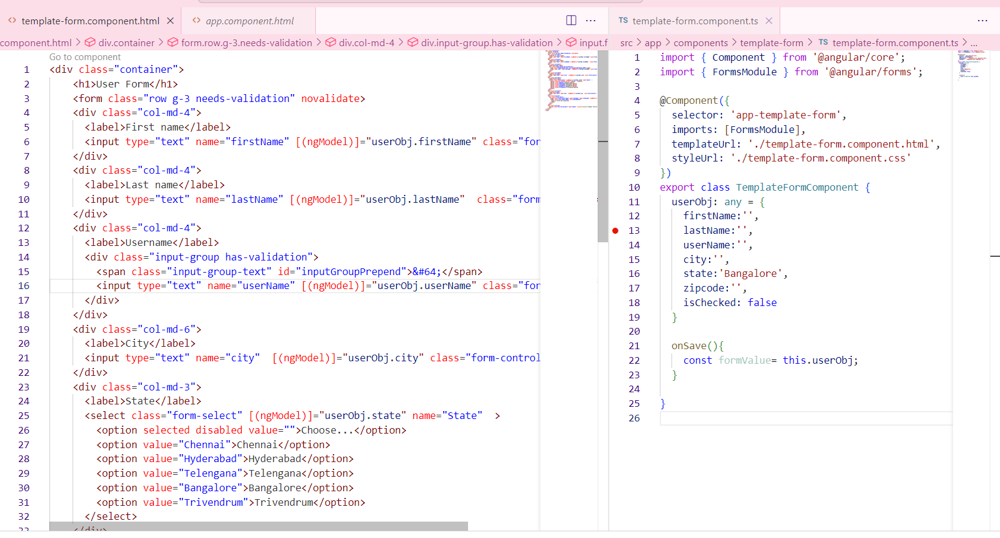

**How to Validate Template Form Use of ngModel in template Form ?**

In template form we need to add validation in HTML.

Creating # property we can validate.

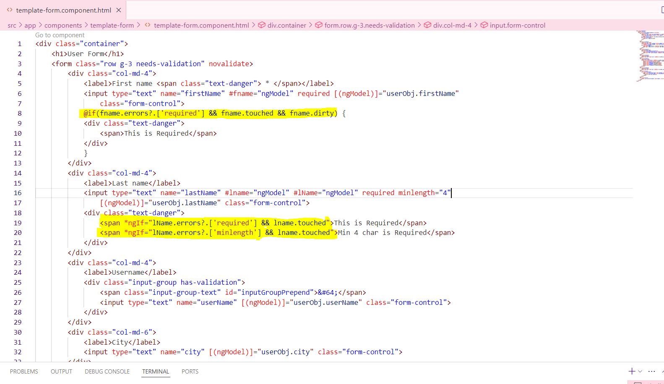

**How to Create Reactive Form in Angular ?**

Import FormGroup and FormControl from @angular/forms.

Initialize the bind form with fields inside the constructor.

All input name should bind in formcontrolName

Reactive form FormGroup is best approach.

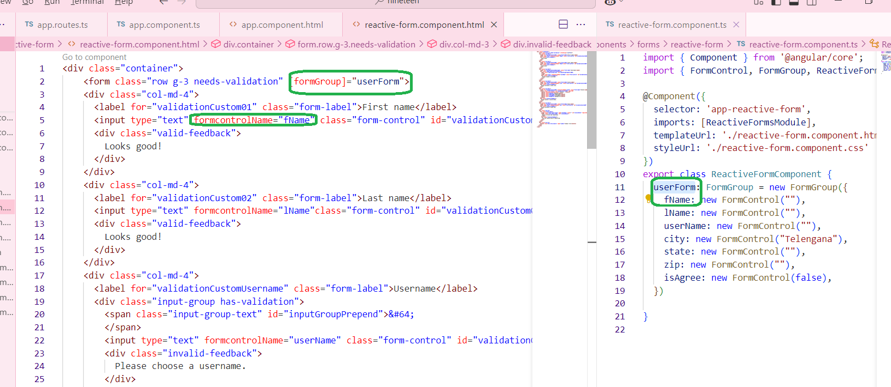

We can get complete form value on submit, so that we can send this object in API.

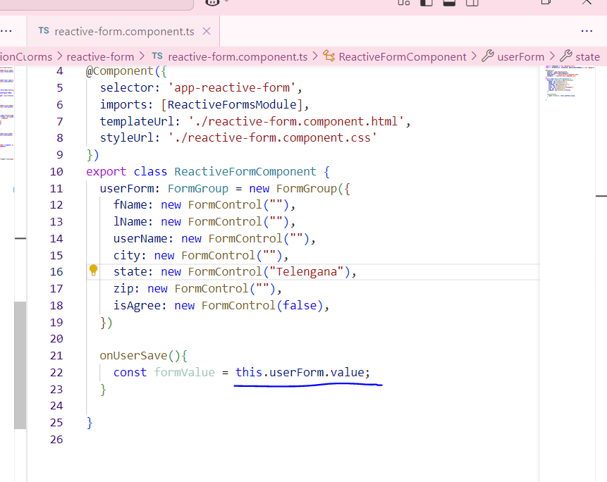

**How to Validate Reactive Form in Angular ?**

In reactive form we need to add validation while creating form.

Validation must pass as an array because there is multiple of validations avail.

Can validate using form. Control example: 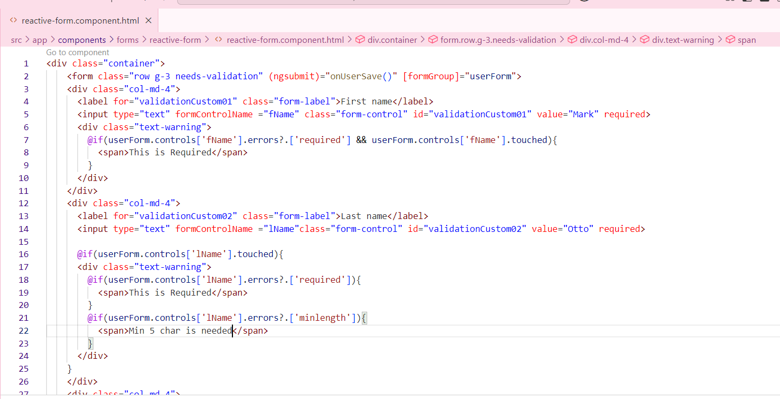

**What is Form Control ?**

**How to Disable Form Control ?**

If need to disable the control for the field.

1.create a constructor.

2.disable that particular field.

We have an enable option also.

Const isValid =this.userForm.valid;-🡪 Whole form valida..

**What is API ?**

**Application programming interface,** **a set of protocols and definitions that allow different software components or programs to communicate with each other and share data.**

**In order to use API first need to add provideHTTPclient() in providers array avail in app.config.ts file.**

**

**What is HttpClient ?**

**What is GET API ?**

**Info related to API…can get here”** [**https://freeapi.miniprojectideas.com/index.html**](https://freeapi.miniprojectideas.com/index.html)**”**

**In order to run to specific port use command as “ng serve --port 4209”**

**GET RECORDS**

**How to Integrate GET API call ?**

**How to Store api Response ?**

**What are Fake API ?**

**What is POST API ?**

**TO CREATE RECORDS**

**How to Integrate POST API ?**

**POST API With Template form ?**

**What is PUT API ?**

**TO UPDATE EXISTING RECORDS**

**How to Integrate PUT API ?**

**PUT API With Template form ?**

**What is DELETE API ?**

**TO DELETE EXISTING RECORDS:**

**How to Integrate DELETE API ?**

**Show confirmation before Deleting Record**

**What is Resource API ?**

**For which Purpose We have to use Resource API in angular 19?**

**How to make api call with Resource API in angular 19?**

**What are loader and reload function in Resource API in angular 19?**

**What is Service ?**

**For which Purpose We have to use Service ?**

**How to create api call Function in Service ?**

**Angular CRUD with api with Service call Functions ?**

**What are Life Cycle Events ?**

**Types of Life cycle Events ?**

**Which one We mostly Use and Their UseCase ?**

**What are Pipes ?**

**Default Pipe in angular ?**

**How to Create Custom Pipe ?**

**What is @Input in angular?**

**What is @Output() in angular ?**

**What is EventEmitter in angular?**

**How to Create Reusable component in angular ?**

**How to create interface ?**

**How to create class ?**

**When to use class or interface ?**

**How to Implement Login Page angular ?**

**What is Hard Code Login angular ?**

**How to Validate User With API angular ?**

**What is guard in angular ?**

**How to Create canActivate guard in angular ?**

**What is ViewChild ?**

**How to create viewChild for Element Reference ?**

**How to create viewChild for Component Reference ?**

**How to use signal with Forms.**

**Creating individual FormControl instead of creating Form.**

**Use of async Pipe with API call.**

**How to use resource api to make api calls.**

**use of Subject in Filter textbox**

**How to Use ngTemplate ?**

**How to Use ng-container ?**

**How to Use ngTemplateOutlet with ngTemplate ?**

**How to Use Interceptor ?**

**How to Do JWT token Login ?**

**How to send token in headers in api ?**

**CRUD**

**Dependency Injection**

**Input and output**

**Lazy loading**